Elyra- An Emotion-Based Music Recommender

AN INDUSTRIAL ORIENTED MINI PROJECT REPORT

Submitted

In the partial fulfillment of the requirement for the award of degree

BACHELOR OF TECHNOLOGY

in

COMPUTER SCIENCE AND ENGINEERING

by
S. Harshini (23B81A05L6)
D. Sindhu (23B81A05P6)
T. Sreya Sree (23B81A05P8)

Under the Guidance of

Dr. M. Sridevi

Associate Professor Dept. of CSE

Department of Computer Science and Engineering

CVR COLLEGE OF ENGINEERING
(An UGC Autonomous Institution, Affiliated to JNTUH, Accredited by NBA, and NAAC) Vastunagar, Mangalpalli (V), Ibrahimpatnam (M), Ranga Reddy (Dist.) - 501510, Telangana State.

April-2026

i


CVR COLLEGE OF ENGINEERING
(An UGC Autonomous Institution, Affiliated to JNTUH, Accredited by NBA, and NAAC) Vastunagar, Mangalpalli (V), Ibrahimpatnam (M), Ranga Reddy (Dist.) - 501510, Telangana State.

DEPARTMENT OF COMPUTER SCIENCE AND ENGINEERING

CERTIFICATE

This is to certify that the project work entitled “Elyra-An Emotion-Based Music Recommender” is being submitted by S. Harshini (23B81A05L6) and D. Sindhu (23B81A05P6) and T. Sreya Sree (23B81A05P8) in partial fulfillment of the requirement for the award of the degree of Bachelor of Technology in Computer Science and Engineering, during the academic year 2026-2027.

The result embodied in this project work has not been submitted to any other University or Institute for the award of any degree or diploma.

Signature of the project guide Signature of the Professor Incharge

Dr. M. Sridevi Dr. Raghava .M, PhD

Professor Professor CSE, Associate Dean, Alumni Affairs

External Examiner

ACKNOWLEDGMENT

The satisfaction that accompanies the successful completion of any task would be incomplete
without the mention of the people who made it possible and whose encouragement and
guidance has been a source of inspiration throughout the course of the project.

It is a great pleasure to convey our profound sense of gratitude to our principal Prof. K. Rammohan Reddy, and Dr. A. Vani Vathsala, Professor and Head of CSE Department, CVR College of Engineering, for having been kind enough to arrange necessary
facilities for executing the project in the college.

We deem it a pleasure to acknowledge our sense of gratitude to our project guide Dr. M. Sridevi under whom we have carried out the project work. Her incisive and objective guidance and
timely advice encouraged us with constant flow of energy to continue the work.

We wish a deep sense of gratitude and heartfelt thanks to management for providing excellent lab
facilities and tools. Finally, we thank all those whose guidance helped us in this regard.
We place highest regards to our Parents, our Friends and Well-wishers who helped a lot in
making the report of this project.

S.Harshini (23B81A05L6)
D.Sindhu(23B81A05P6)
T.Sreya Sree (23B81A05P8)

TABLE OF CONTENTS

 |  |  | Page No.
 |  | Abstract | 1
1 |  | INTRODUCTION | 2-5
 | 1.1 | Motivation | 2
 | 1.2 | Problem Statement | 3
 | 1.3 | Project Objectives | 4
 | 1.4 | Project Report Organization | 5
2 |  | LITERATURE REVIEW | 6-7
 | 2.1 | Existing Work | 6
 | 2.2 | Limitations of Existing work | 7
3 |  | REQUIREMENT ANALYSIS | 8-9
 | 3.1 | Software requirements | 8
 | 3.2 | Hardware requirements | 8
 | 3.3 | User requirements | 9
4 |  | SYSTEM DESIGN
 | 4.0 | Proposed System Architecture
 | 4.1 | Proposed Methods/Algorithms
 | 4.2 | Class/Use Case/Activity/Sequence Diagrams
 | 4.3 | Datasets and Technology Stack
5 |  | IMPLEMENTATION
 | 5.1 | Front Page Screenshot
 | 5.2 | Results and Discussion
 | 5.3 | Testing
 | 5.4 | Validation

6 |  | CONCLUSION
 | 6.1 | Conclusion
 | 6.2 | Future Scope
 |  | REFERENCES
 |  | APPENDIX:(if any like Published paper /source code)

ABSTRACT

Elyra is a web-based platform designed to revolutionize the music streaming experience by dynamically matching audio content with a user’s real-time emotional state. Current music applications offer extensive libraries but typically rely on static genres or historical data, often failing to capture the user's immediate mood or psychological needs, which can result in a repetitive or jarring listening experience. Because of this lack of emotional synchronization, many users spend significant time manually searching for songs that fit their current feelings, leading to a fragmented and less immersive experience. Elyra addresses this issue by allowing users to securely sign up and log in using Firebase Authentication to access a personalized dashboard. The platform incorporates a computer vision-based emotion detection module that analyzes facial expressions via the webcam to identify emotional triggers like stress, joy, or fatigue. Based on this analysis, the system automatically filters and recommends curated playlists categorized by emotional resonance, such as Calming, Uplifting, or Focus-oriented. The platform includes an NLP-based chatbot that suggests tracks based on conversational mood cues and provides context for why certain songs were chosen. Utilizing Firebase Firestore or MySQL for robust data management, Era aims to enhance mental well-being and user engagement through a seamless, empathetic, and technologically advanced approach to digital music delivery.

CHAPTER-1

INTRODUCTION

MOTIVATION

In today’s fast-paced digital era, many music listeners face difficulties in finding the right soundtrack for their current state of mind due to "choice paralysis," static playlists, and overwhelming content across multiple streaming platforms. Individuals often struggle to identify tracks relevant to their immediate mood, especially when dealing with stress, exhaustion, or a specific need for emotional focus. Limited personalization, generic recommendations, and repetitive historical data further increase user frustration and disconnect. Ensuring a seamless, mood-aware experience, accurate emotion mapping, and real-time audio assistance is essential to improve the psychological impact of digital media and overall user well-being.
The goal of the Elyra Emotion-Based Music Platform is to provide an intuitive and centralized system where users can easily align their auditory environment with their internal feelings. The platform allows users to generate playlists based on real-time emotion detection, facial expressions, and conversational cues, with the support of an AI chatbot for instant track guidance. By utilizing a user-friendly interface, secure authentication, and a responsive emotion-mapping engine, Elyra aims to bridge the gap between human sentiment and digital music services, enhancing accessibility, emotional awareness, and user satisfaction.

PROBLEM STATEMENT

Many music listeners face difficulties in finding tracks that match their current emotional state due to scattered playlists, lack of personalization, and complex mood-mapping criteria. Existing platforms often provide incomplete or hard-to-understand recommendations based on history, making it challenging for users to identify music relevant to their immediate needs. Stressed and overwhelmed populations are especially affected due to limited guidance in navigating vast audio libraries. The absence of a centralized and interactive system leads to "decision fatigue" and underutilization of music as a tool for mental well-being.
Hence, there is a need for a user-friendly and centralized platform that simplifies mood-based discovery and improves accessibility.
Additionally, users struggle with understanding how specific audio features, required energy levels, and tempos affect their mood, which discourages intentional listening. Language and genre barriers further limit access for many global users seeking emotional relief. There is also a lack of real-time assistance and personalized recommendations on existing portals through facial or conversational cues. Security and trust issues arise due to inconsistent authentication mechanisms for storing personal emotional data. Addressing these challenges is essential to ensure the effective delivery and utilization of an emotionally intelligent music experience.

PROJECT OBJECTIVES

User Authentication: Enable users to securely register, log in, and manage personalized access to mood- based music profiles and saved preferences.
Centralized Mood Discovery: Provide a unified platform where users can search and browse music tracks and playlists based on emotional states, energy levels, and genres.
Emotion Identification: Help users easily identify music they resonate with by filtering audio content using real-time facial expression analysis and psychological triggers.
AI Chatbot Assistance: Integrate an AI chatbot (Eylara) to offer real-time guidance, answer user queries, and assist in understanding the emotional impact of specific tracks.
Detailed Music Information: Display complete and transparent information including track tempo, energy levels, emotional mapping, and artist details for an intentional listening experience.
User-Friendly Navigation: Design an intuitive and accessible interface to ensure easy navigation for users of all backgrounds, including those seeking stress relief or emotional regulation.

PROJECT REPORT ORGANIZATION

This Project Report presents a detailed description of the problem, design challenges, proposed methodologies, and implementation of the Eylara Emotion-Based Music Platform developed to address real-world issues related to accessibility and awareness of personalized audio therapy. The report explains the system architecture, technologies used, and functional modules that enable users to efficiently discover and access relevant music tracks.
This report is organized into six chapters. Following this introductory chapter.
Chapter 1: This chapter introduces the Eylara Emotion-Based Music Platform and its goal of delivering emotion-based personalized music.
Chapter 2: Describes the literature survey, analysis of the existing emotion-based music platforms, and the proposed Eylara solution.
Chapter 3: Defines the software requirements, hardware requirements, and user requirements of the system.

Chapter 4: Explains the system design using use-case diagrams, architecture diagrams, activity diagrams, and sequence diagrams.
Chapter 5: Discusses the implementation details and testing of the platform using various tools and technologies.
Chapter 6: Presents the conclusion of the project and outlines the future scope and enhancements of the
Eylara Emotion-Based Music Platform.

LITERATURE REVIEW

Existing Work

Today, several music streaming portals and digital platforms provide access to vast libraries of audio content and personalized recommendations. Global and local-level applications offer details related to music in areas such as entertainment, relaxation, focus, motivation, and mental well-being. Many of these platforms require users to register or log in to access personalized services, track listening history, or download artist-related documents. Users can browse tracks by category, genre, or artist type and view basic information such as album details and release dates.
Despite these advancements, existing systems often suffer from limitations such as recommendations based solely on history, complex navigation, and lack of user-friendly emotional integration. Many platforms present information in a text-heavy format, making it difficult for users to understand track energy, mood compatibility, and audio characteristics. Language barriers and limited emotional literacy further restrict access, especially for users seeking therapeutic and psychologically supportive music experiences.

LIMITATIONS OF EXISTING WORK

Lack of Centralization: Emotional music data is spread across multiple streaming platforms and genres, making it difficult for users to find complete and mood-relevant tracks in one place.
Limited Awareness: Many users are unaware of how specific audio frequencies or tempos affect their mental state, resulting in low emotional resonance and underutilization of music therapy.
Complex Mood Mapping: Existing platforms often present recommendation algorithms in a complex manner, making it hard for users to understand whether a track truly qualifies for their current psychological state.
Absence of Real-Time Assistance: Most current systems do not provide interactive support or instant mood-based guidance, leaving users without help when they have emotional queries or face selection difficulties.
Accessibility Issues: Language barriers, poor user interface design, and limited emotional literacy restrict access for users seeking therapeutic and psychologically supportive listening experiences.

REQUIREMENT ANALYSIS

Software Requirements

The development of the Eylara Emotion-Based Music Platform requires a reliable and modern software environment to ensure scalability, security, and user-friendly interaction. The following software components are used for the successful implementation of the system:
Operating System: Windows – Used as the primary development and execution environment.

Frontend and Full-Stack Framework: Next.js 13: A React-based framework used to build fast, scalable, and server-rendered web applications. Tailwind CSS: A utility-first CSS framework used to design responsive, clean, and modern user interfaces. TypeScript: A superset of JavaScript that provides static typing, improving code reliability and maintainability.
Additional Frontend Technologies: HTML5: Used for structuring web content and layout. CSS3: Used for basic styling and layout design. JavaScript (ES6+): Used for client-side logic, interactivity, and dynamic content rendering.
Backend Services: Firebase: Used for user authentication, real-time database management, and secure backend services.
API Integration: AI Emotion API: Used to provide real-time facial recognition and guidance to users regarding their emotional state.
Development Environment: Visual Studio Code: A lightweight and efficient code editor with support for extensions for HTML, CSS, JavaScript, TypeScript, and Firebase integration.

Hardware Requirements

Processor: Intel Core i5 or higher RAM: 8 GB (minimum) Storage: 500 GB SSD

User Requirements

User Registration and Profile Management: Users must be able to create an account using an email address or phone number. Users should be able to log in securely and manage their profiles, including updating personal details and music preferences.
Mood Discovery and Browsing: Users should be able to browse and search music tracks based on categories such as joy, relaxation, focus, and stress relief. The system should allow users to filter music according to emotional intensity.
Emotion Identification: Users should be able to check their current mood for various music recommendations by providing basic facial expressions or psychological information.
Detailed Music Information: Users should have access to complete track details, including emotional mapping, tempo, energy levels, and artist background.
AI Chatbot Assistance: Users should be able to interact with an AI chatbot to receive real-time guidance, clarifications, and answers to queries related to mood-based music.
Playlist Guidance and Tracking: Users should receive step-by-step guidance on how to curate playlists and be able to track saved or shortlisted tracks for future reference.
Security and Privacy: The system should ensure secure authentication and protect user data, maintaining privacy and confidentiality at all times.

SYSTEM DESIGN

Proposed System architecture

The proposed system architecture for the Elyra: An Emotion-Based Music Platform is designed as a full-stack web application that provides dynamically matching audio content to user moods. The frontend is built using Next.js 13, Tailwind CSS, and TypeScript to deliver a responsive, intuitive, and user-friendly interface.
Users can browse, search, and filter tracks based on emotional categories and intensity, ensuring easy navigation and accessibility.
The backend uses Firebase for secure user authentication, real-time data storage, and management of music track details and user profiles. Our system is integrated to provide and guide users through emotion detection and personalized playlist generation. Role-based access control and secure data handling ensure privacy and reliability. Overall, the architecture is designed to be scalable, efficient, and capable of supporting future enhancements.

Proposed methods /Algorithms

The Elyra Emotion-Based Music Platform implements a set of structured methods and algorithms to provide efficient access to personalized audio therapy and improve user experience. The proposed methods are described below:
User Registration and Authentication Method: The system uses Firebase Authentication to allow users to register and log in securely using email-based authentication. Authentication algorithms validate user credentials, manage sessions, and ensure secure access to personalized emotional profiles and music preferences.
Mood Search and Filtering Algorithm: The platform implements search and filtering mechanisms that allow users to browse tracks based on categories such as joy, relaxation, focus, and stress relief. Filters are applied using audio parameters like tempo, energy, and valence to display relevant music tracks efficiently.
Emotion Matching Algorithm: An emotion matching algorithm compares user-provided facial expressions or mood inputs with music metadata stored in the database. Based on this comparison, the system identifies and displays tracks for which the user is emotionally aligned, reducing confusion and improving discovery.
AI Chatbot Assistance Algorithm: The integrated AI chatbot uses natural language processing techniques to understand user queries and provide real-time responses. It assists users in understanding track details, mood benefits, and playlist procedures, enhancing user interaction and psychological support.
Data Storage and Retrieval Method: All music metadata, user profiles, and interaction records are stored and managed using Firebase Realtime Database. Firebase ensures efficient data storage, real-time synchronization, and fast retrieval of information, enabling a responsive and scalable system.

Class Diagram

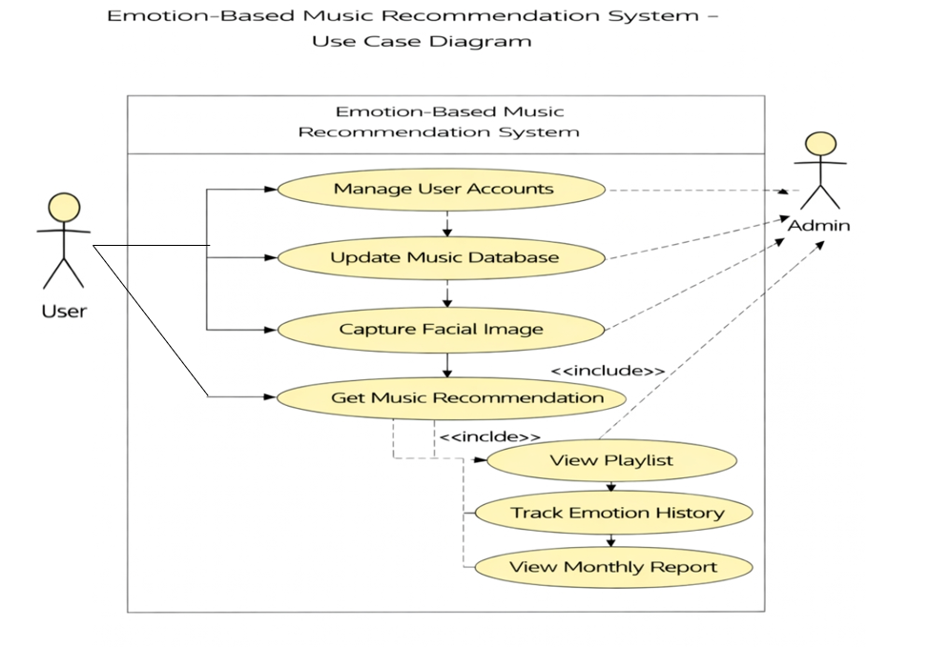

4.2.2
  - Datasets and Technology stack
Since the Eylara Emotion-Based Music Platform is dynamic and user-driven, it does not rely on a static dataset. All data is securely stored and synchronized using Firebase services. The main types of data handled by the system include:
UserData: Information collected during user registration and authentication such as name, email address, and unique user ID, managed through Firebase Authentication.
MusicData: Details of music tracks including track name, genre, emotional mapping, tempo, energy levels, artist details, and psychological impact information.
UserInteractionData: Data related to user preferences, mood history, chatbot interactions, and search history to enhance personalization and usability.
Technology Stack Frontend: Next.js 13: React-based framework used for building scalable, fast, and server-rendered web applications. Tailwind CSS: Utility-first CSS framework used to design responsive and modern user interfaces.
Authentication: Firebase Authentication: Used for secure user login, registration, and session management.
Backend & Database: Firebase Realtime Database / Firestore: Used for storing user profiles, music data, and interaction records with real-time synchronization.
AI Integration: AI Emotion API: Used to provide real-time assistance, analyze user moods, and guide users through personalized music discovery and mental well-being.
Development Tools: Visual Studio Code: Integrated Development Environment used for coding and debugging. Node.js & npm: Runtime environment and package manager used for dependency management and development support.

IMPLEMENTATION
  - Front page screenshot

RESULTS AND DISCUSSION

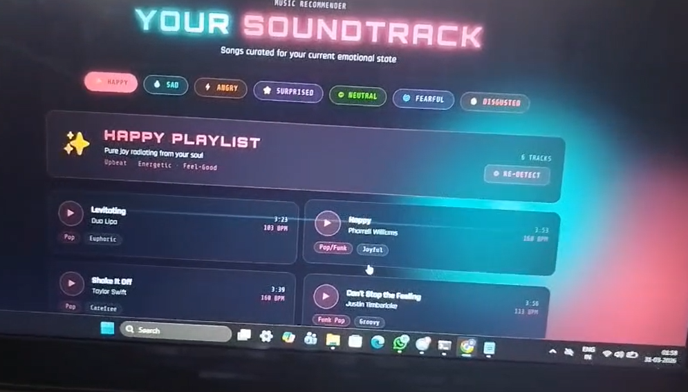
  - Testing

  - Validation

CONCLUSION

Conclusion
The Eylara Emotion-Based Music Platform successfully demonstrates the effective use of modern web technologies to simplify access to personalized audio therapy. By providing a centralized and user-friendly interface, the platform enables users to easily discover, understand, and explore music tracks based on mood and categories. The integration of secure authentication and real-time data management ensures reliability and data security.
This project highlights the practical implementation of full-stack development, combining a responsive frontend with a scalable backend to address real-world challenges related to mental well-being and awareness. The inclusion of an AI-powered chatbot enhances user interaction by offering real-time assistance and guidance, reducing confusion and improving user experience.
Overall, the project achieves its intended objectives by bridging the gap between listeners and emotionally intelligent music services. While the current system provides essential functionalities, it can be further enhanced with features such as multilingual support, real-time biometric tracking, and integration with health monitoring apps, making it a strong foundation for future development and academic research.

Future Scope

  - Multilingual Support: Implement support for multiple regional languages to improve accessibility for users from diverse linguistic and cultural backgrounds seeking audio therapy.
Biometric Mood Tracking: Integrate real-time biometric tracking using wearable devices allow users to monitor the physiological impact of music on their stress levels.

Direct Streaming Integration: Enable integration with official music streaming APIs like Spotify or Apple Music to allow users to play recommended tracks directly through the platform.

Personalized Music Recommendations: Use AI and data analytics to recommend tracks based on user profile, historical emotional data, and previous listening interactions.

Mobile Application Development: Develop a mobile application using technologies such as React Native or Flutter to increase accessibility on smartphones for on-the-go mood regulation.

Admin Dashboard: Create an admin panel for managing music libraries, users, content updates, and system analytics to ensure library accuracy and efficiency.

Mood Journaling and Verification: Allow users to log their emotional journey securely and integrate verification mechanisms to streamline personal mental health progress tracking.

Enhanced Security and Privacy: Implement advanced security features such as two-factor authentication and encrypted data storage to protect sensitive emotional and user data.

Analytics and Reporting: Incorporate analytics tools to track user engagement, track popularity, and system performance for continuous improvement of the recommendation engine.

